**Experiment No. 5**

1. **Aim/Overview of the practical:**

Create a webapp and publish on Azure using Visual Studio.

1. **Code for practical:**

* Install and open Visual Code in your computer.
* Click on New project > ASP.NET Core Web App.
* Enter name and select path for your project, then click on Next button.

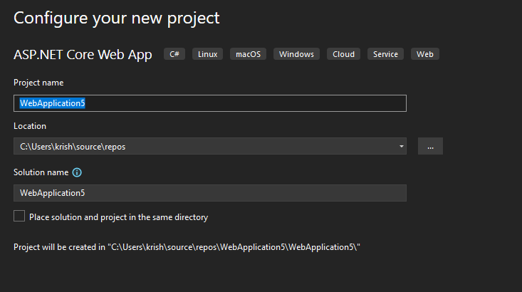

* Select the framework NET 6.0 and click on create button.
* Web App will be created in few seconds. Now make change in Pages>index.cshtml.

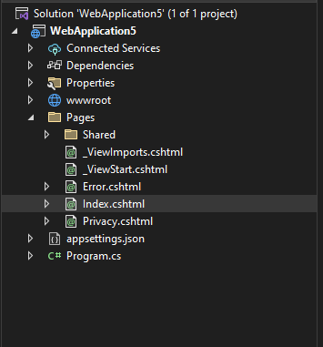

* To Publish webapp, click on Build >Publish from top menubar.

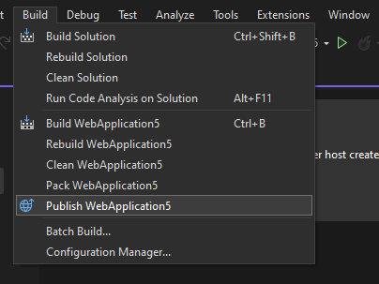

* A dialog box will open. Click on Azure > Azure app service.
* Sign In with your azure account and select resource in which you want to publish.

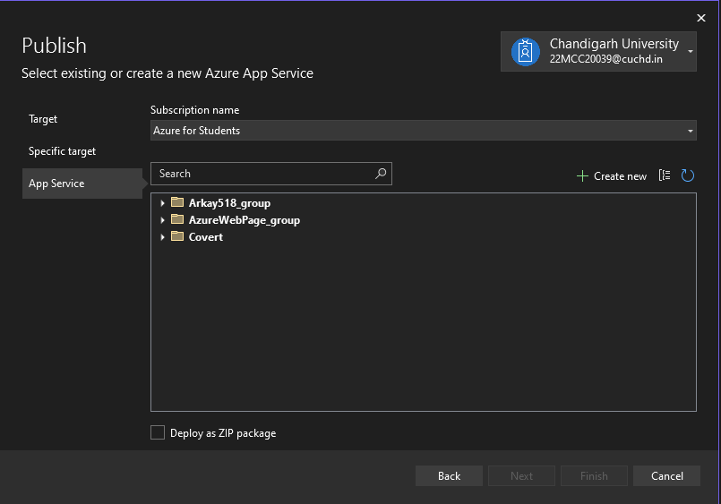

* The click on Create New and Enter details such as Name, Subscription name, Plan

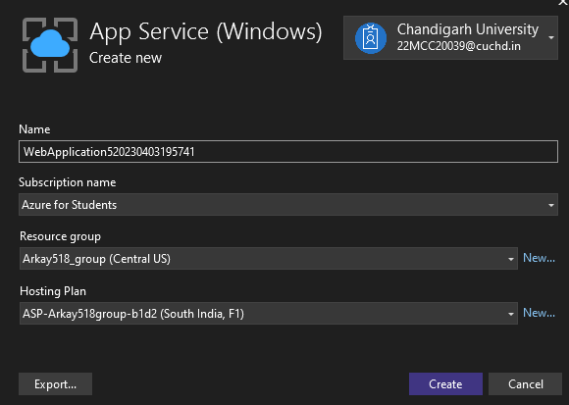

* Click on Create button. New resource will be created for your web app in few moments. 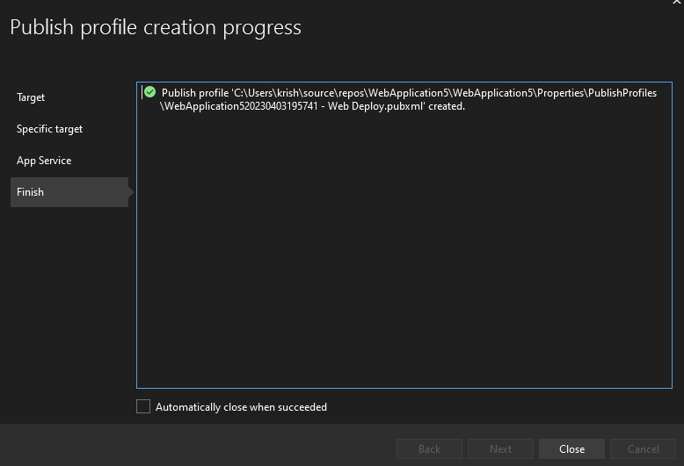
* Click on Finish button and your Webapp will be deployed.

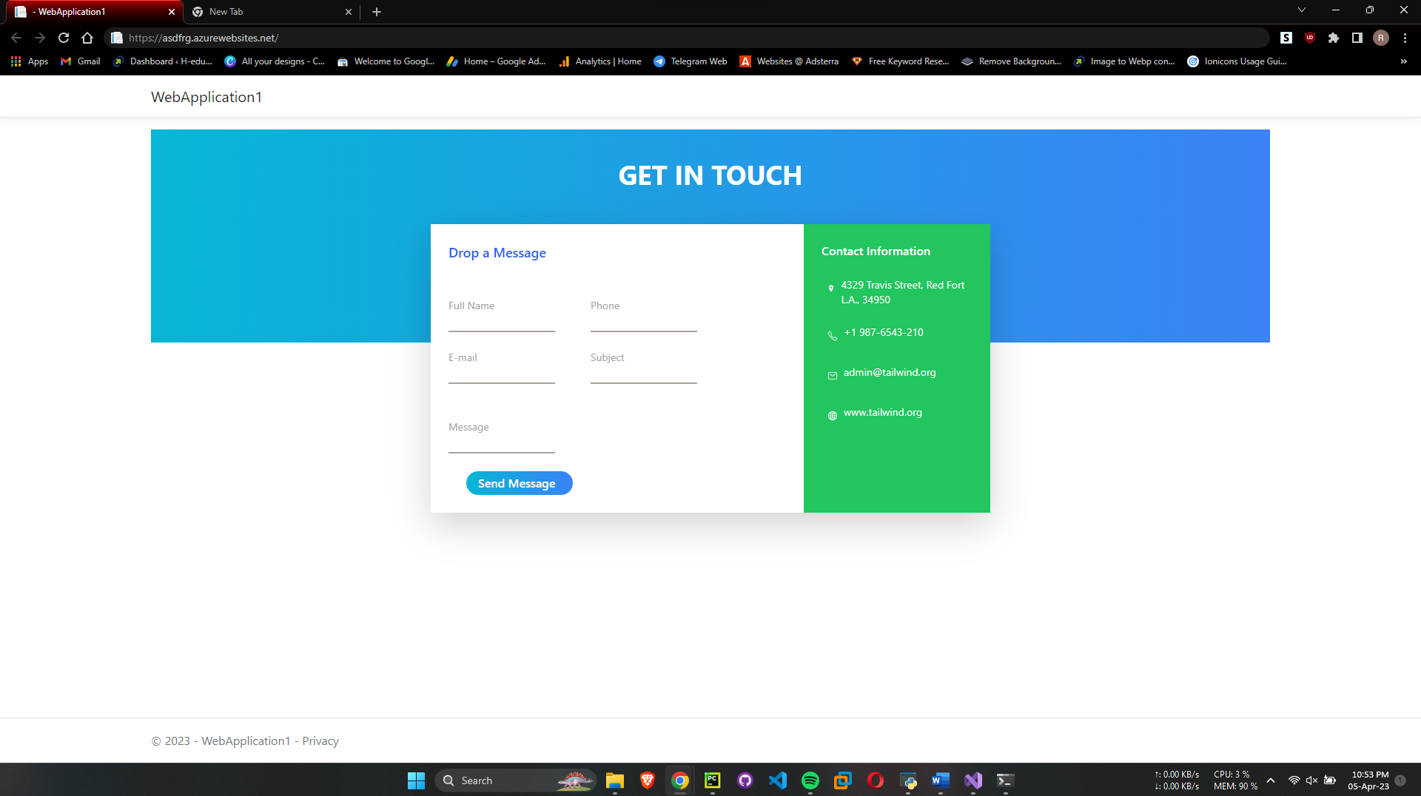

**************************************** **THE END** ***********************************************